**Exercise 14b**

*Create a Kubernetes Cluster in DigitalOcean and Deploy Cassandra*

**Prior Knowledge**

Unix Command Line Shell

YAML

Completion of Ex 14a

**Learning Objectives**

See how Cassandra replicates

Introduction to Kubernetes

**Software Requirements**

Browser

kubectl

**Overview**

In this exercise we are going to instantiate a Kubernetes cluster in DO, then install a Cassandra ring onto the kubernetes cluster. Finally we will do some load-testing.

1. If you have left the cluster running from Ex14a, go straight to **step 2**   
   1. Otherwise redo the steps to create a cluster:

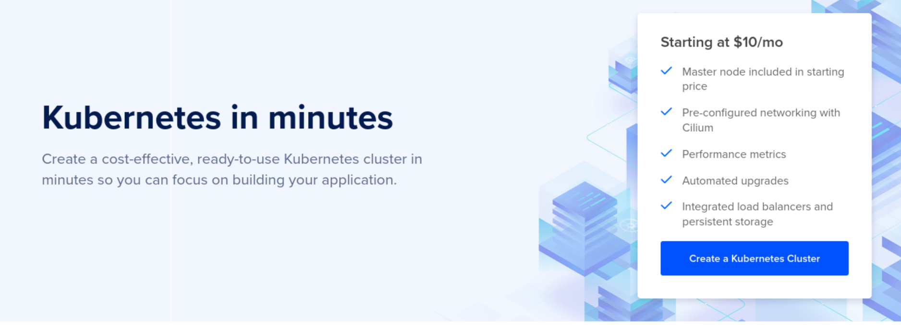

* 1. Make sure you install the monitoring 1-click app.
  2. Download the config file, then:

mv ~/Downloads/k8s-cass-kubeconfig.yaml ~/.kube/  
  
 In your terminal window:  
 export KUBECONFIG=~/.kube/k8s-cass-kubeconfig.yaml

(There are also other things we can do, but this works fine)

* 1. Check it works:

kubectl get all

You should see something like:  
  
NAME TYPE CLUSTER-IP EXTERNAL-IP PORT(S) AGE

service/kubernetes ClusterIP 10.245.0.1 <none> 443/TCP 45m

1. Now let’s make a directory for our Cassandra YAMLs:

mkdir ~/cassandra

1. There are only two small YAML files required to get Cassandra running. They come from this webpage: <https://kubernetes.io/docs/tutorials/stateful-application/cassandra/>

Because we need to modify one of them, let’s download them:

cd ~/cassandra

wget https://k8s.io/examples/application/cassandra/cassandra-service.yaml

wget https://k8s.io/examples/application/cassandra/cassandra-statefulset.yaml

1. Take a look at the cassandra-service.yaml:  
     
   It is really simple (for YAML!):  
   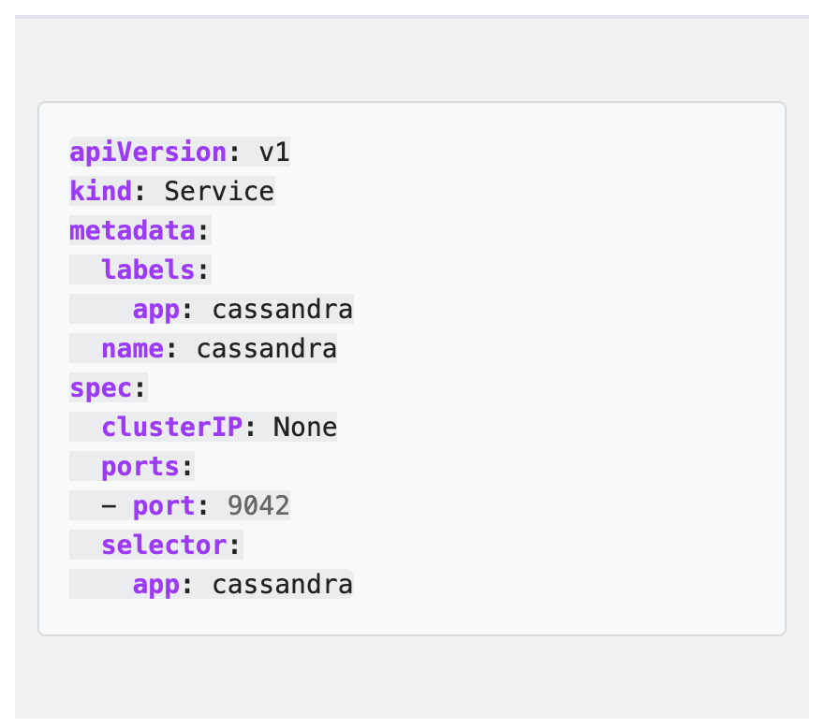
2. This is “kind of” the equivalent of EXPOSE in Docker. You could compare this to the one in the “hello-kubernetes” app if you like.
3. Let’s deploy this:  
   kubectl apply -f cassandra-service.yaml

service/cassandra created

1. Check if it is happy:  
   kubectl get svc

NAME TYPE CLUSTER-IP EXTERNAL-IP PORT(S) AGE

cassandra ClusterIP None <none> 9042/TCP 29s

kubernetes ClusterIP 10.245.0.1 <none> 443/TCP 28m

1. You should see the cassandra service running alongside the kubernetes master. We need this to be in place **before** we start the next part because the different pods need to be able to access each other via port 9042 for the cluster to form.
2. The second file is more complex. It basically defines three things:
   1. The cassandra images and config to start a cassandra container  
        
      

(That is just the start of that bit)

* 1. Defines the storage that will be needed by these servers in a StatefulSet (<https://cloud.google.com/kubernetes-engine/docs/concepts/statefulset>)  
       
     
  2. Defines a StorageClass for deploying into Minikube (a kubernetes distro designed to run on developers’ machines).  
     

1. This YAML will **not work** as is. That is because we need the Kubernetes cluster to request disk from DigitalOcean specifically, not from minikube.
2. Let’s see what StorageClass is available in our DO cluster:  
     
   kubectl get storageclass

NAME PROVISIONER RECLAIMPOLICY VOLUMEBINDINGMODE ALLOWVOLUMEEXPANSION AGE

do-block-storage (default) dobs.csi.digitalocean.com Delete Immediate true 5h26m

This is a pre-configured storage class for DO called do-block-storage

1. We need to edit the YAML file:

code ~/cassandra/cassandra-statefulset.yaml

1. Firstly, lets delete the StorageClass section:

Delete all the highlighted lines:  
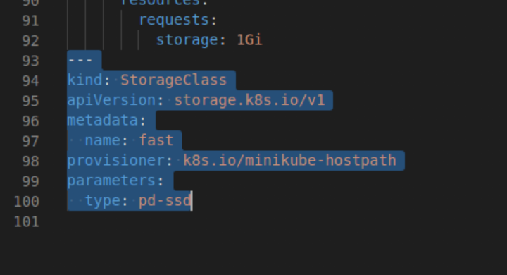

1. Secondly, change the storageClassName from **fast** to **do-block-storage** (which we just identified above).  
   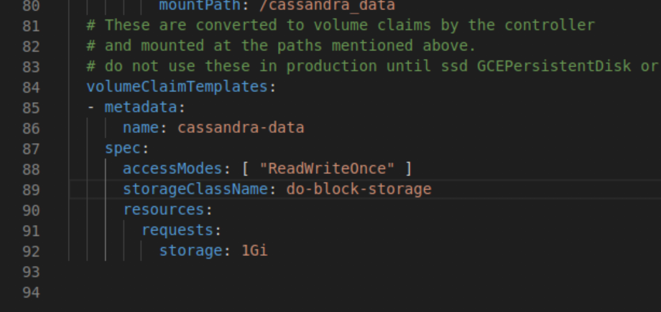
2. Save the file
3. Let’s deploy this now:  
     
   kubectl apply -f cassandra-statefulset.yaml

statefulset.apps/cassandra created

1. We need to wait a bit for this to start. Basically the system is making API requests to DigitalOcean to provision disks.

If you go to k9s, you should see the containers appearing and starting up:

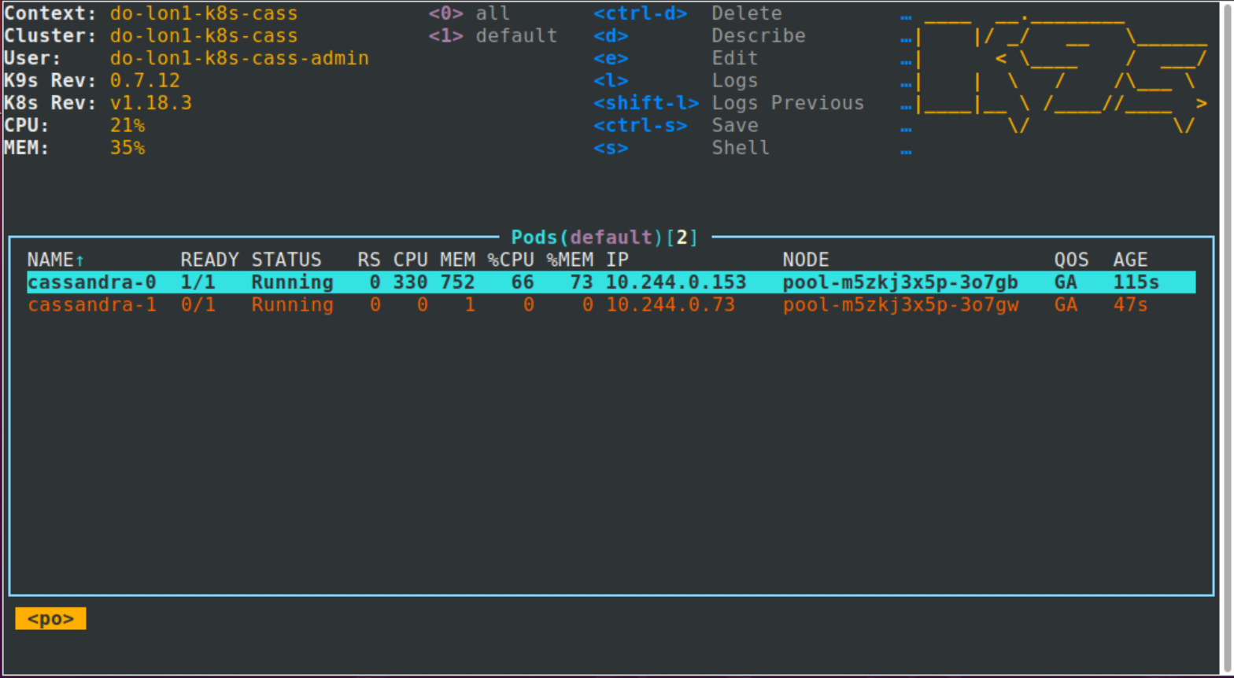

1. If you go to the DigitalOcean control panel you will see **Volumes** being created:  
   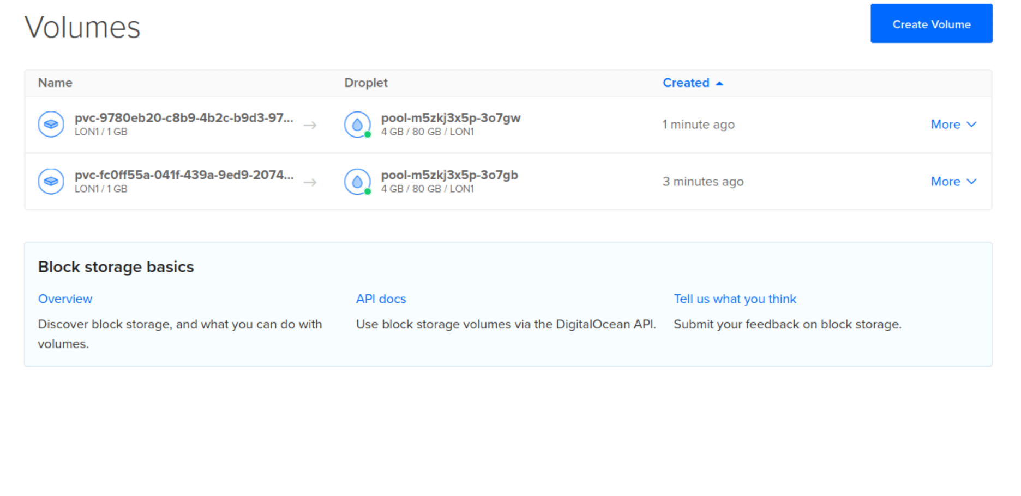
2. After about 5 minutes the cluster should be up and running:  
     
   kubectl get all  
     
   NAME READY STATUS RESTARTS AGE

pod/cassandra-0 1/1 Running 0 10m

pod/cassandra-1 1/1 Running 0 9m21s

pod/cassandra-2 1/1 Running 0 7m37s

NAME TYPE CLUSTER-IP EXTERNAL-IP PORT(S) AGE

service/cassandra ClusterIP None <none> 9042/TCP 5h14m

service/kubernetes ClusterIP 10.245.0.1 <none> 443/TCP 5h42m

NAME READY AGE

statefulset.apps/cassandra 3/3 10m

1. We can now execute commands in the cassandra cluster.

“kubectl exec -ti” is a bit like docker exec. This executes the command that follows -- on the cassandra-0 container instance.  
  
kubectl exec -ti cassandra-0 -- nodetool status

Datacenter: DC1-K8Demo

======================

Status=Up/Down

|/ State=Normal/Leaving/Joining/Moving

-- Address Load Tokens Owns (effective) Host ID Rack

UN 10.244.1.109 89.9 KiB 32 52.6% 70e6195b-3629-4d66-a10c-f345015cf68c Rack1-K8Demo

UN 10.244.0.153 104.55 KiB 32 73.9% 5690399f-6052-439d-b23d-e76e6c152758 Rack1-K8Demo

UN 10.244.0.73 65.81 KiB 32 73.5% c5a95d05-6891-4586-b416-db5b828b3ccf Rack1-K8Demo

1. Now let’s stress test the server. We can do it over the network between our machine and the DO cluster, but be warned this isn’t terribly efficient.  
     
   First, let’s forward the cluster port 9042 to local port 9040. We are choosing 9040 locally because we might still be running cassandra locally on 9042 and we want to be sure we are talking to the remote cluster:  
     
   kubectl port-forward pods/cassandra-0 9040:9042  
     
   You should see:  
     
   Forwarding from 127.0.0.1:9040 -> 9042

Forwarding from [::1]:9040 -> 9042

*Leave that window and* ***start a new terminal window.***

1. Now let’s to a stress test on port 9040:

cassandra-stress write n=100000 -port native=9040 -rate threads=1000

You may see some Java exceptions in the logs (due to networking challenges). Eventually it should finish with something like:  
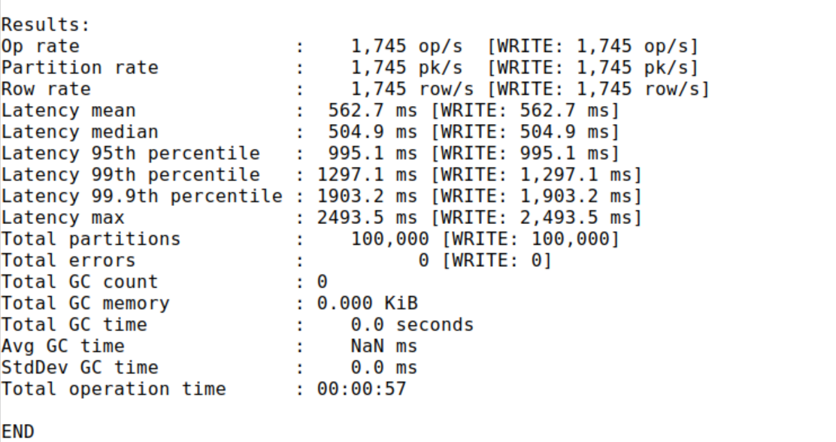

1. Kill the port forwarding process (Ctrl-C).
2. Let’s now do the same test from within the cluster. Use the same window you’ve been using for kubectl before   
   (i.e. the one where you did export KUBECONFIG=)  
   To do this, we can start a new pod and get shell access:  
     
   kubectl apply -f <https://raw.githubusercontent.com/pzfreo/ox-clo/master/code/cass-tools/shell.yaml>

You should see:  
root@pool-gdbxlmdop-3oyjy:/#

1. This is just an Ubuntu container with cassandra tools installed.

Start another window and do   
  
export KUBECONFIG=~/.kube/k8s-cass-kubeconfig.yaml  
  
Let’s check it started:  
  
kubectl get all

NAME READY STATUS RESTARTS AGE

pod/cassandra-0 1/1 Running 0 4h27m

pod/cassandra-1 1/1 Running 0 4h26m

pod/cassandra-2 1/1 Running 0 4h24m

**pod/casstool 1/1 Running 0 23m**

NAME TYPE CLUSTER-IP EXTERNAL-IP PORT(S) AGE

service/cassandra ClusterIP None <none> 9042/TCP 9h

service/kubernetes ClusterIP 10.245.0.1 <none> 443/TCP 9h

NAME READY AGE

statefulset.apps/cassandra 3/3 4h27m

1. Inside kubernetes, the networking is different to the real world. We need to know a host IP to contact the pods on:

kubectl describe svc/cassandra   
  
 Name: cassandra

Namespace: default

Labels: app=cassandra

Annotations: Selector: app=cassandra

Type: ClusterIP

IP: None

Port: <unset> 9042/TCP

TargetPort: 9042/TCP

Endpoints: **10.244.0.153**:9042,10.244.0.73:9042,10.244.1.109:9042

Session Affinity: None

Events: <none>

Choose one of the IP addresses listed as an endpoint. Make a note

(in my case 10.244.0.153)

1. We can now get a command-line in that container:

kubectl exec -it casstool -- bash

1. Now let’s redo that test from within the cluster (with your IP address)  
     
   cassandra-stress write n=100000 -rate threads=1000 -node 10.244.0.153

Unless you have a massively fast connection from your machine to the DO datacentre, you should see much better performance now:

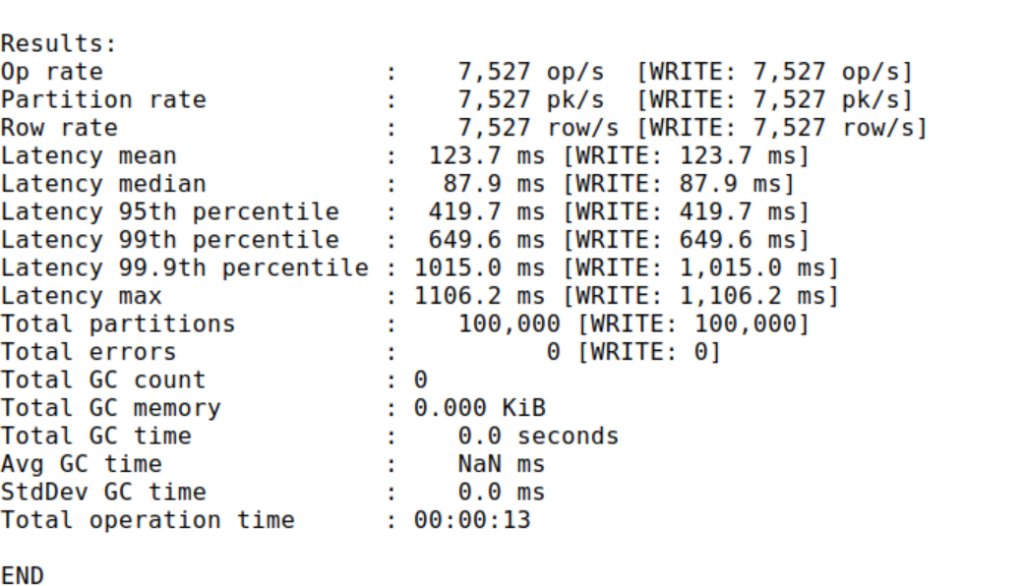

1. Now let’s add another node into the cluster.

Quit that container shell (Ctrl-D) and execute this command:

kubectl scale --replicas 4 statefulset/cassandra

Wait for the new instance to be live:

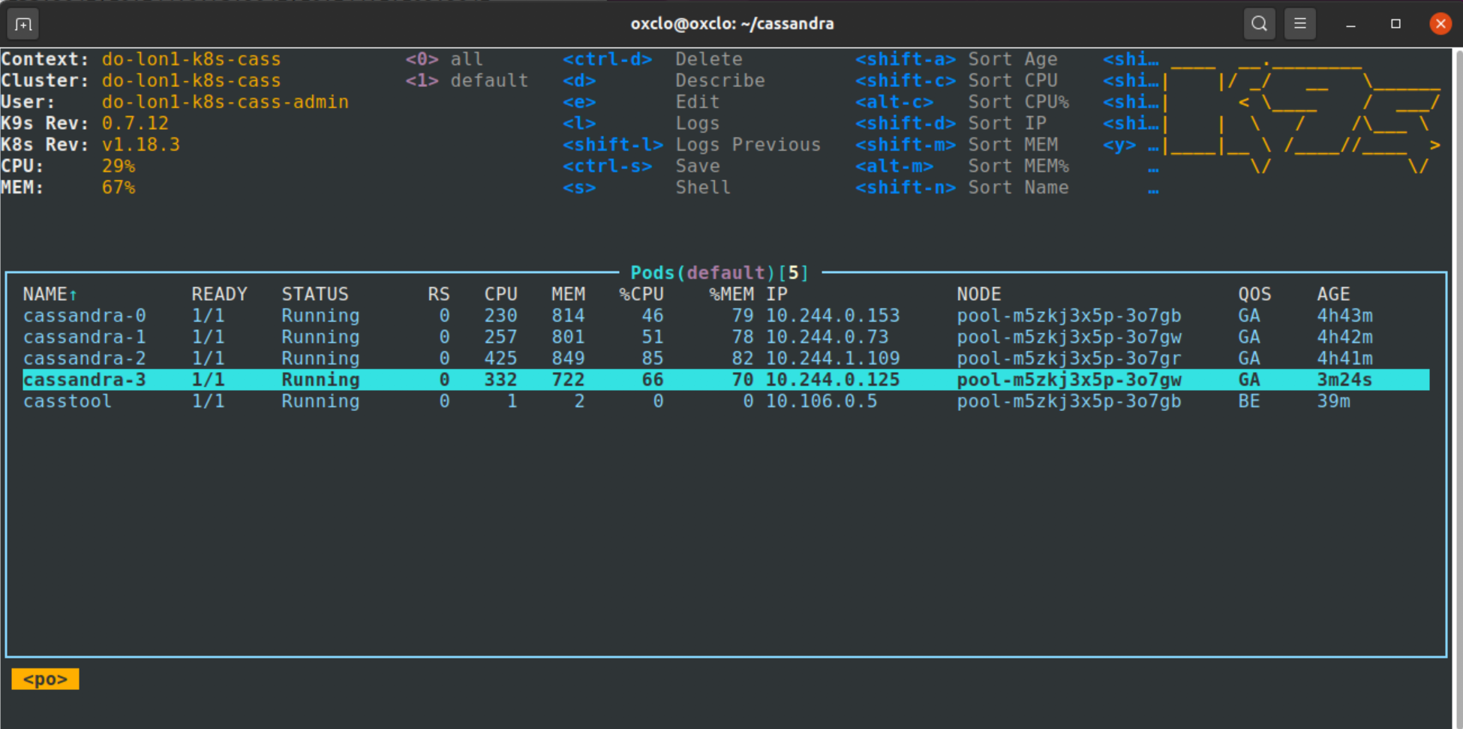

1. Now lets ask the status from Cassandra:  
   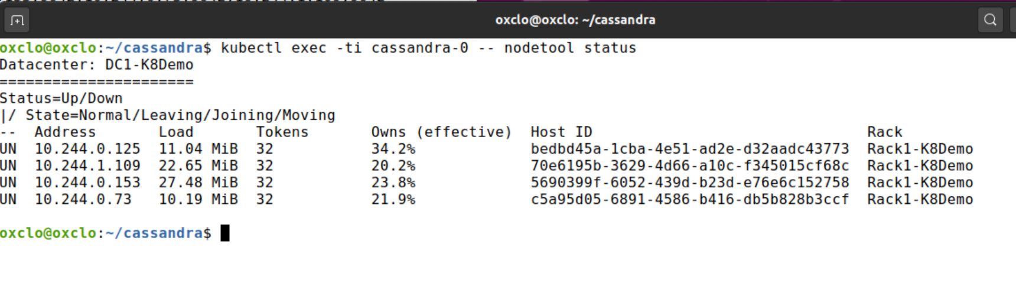
2. Rerun the stress test (Steps 29 and 30).

Unfortunately, we may not be any faster - because now at least 2 pods are on one node (4 pods, 3 nodes).

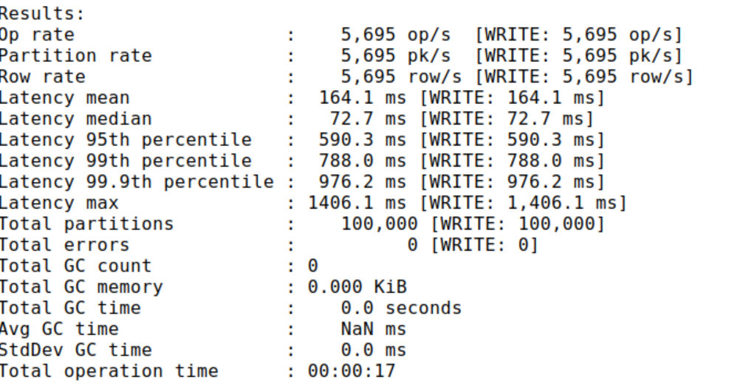

1. Let’s fix that:

Go to the Digital Ocean **Kubernetes**-> **k8s-cass**-> **Nodes**. Click on the Node Pool …   
Now choose **Resize or Autoscale**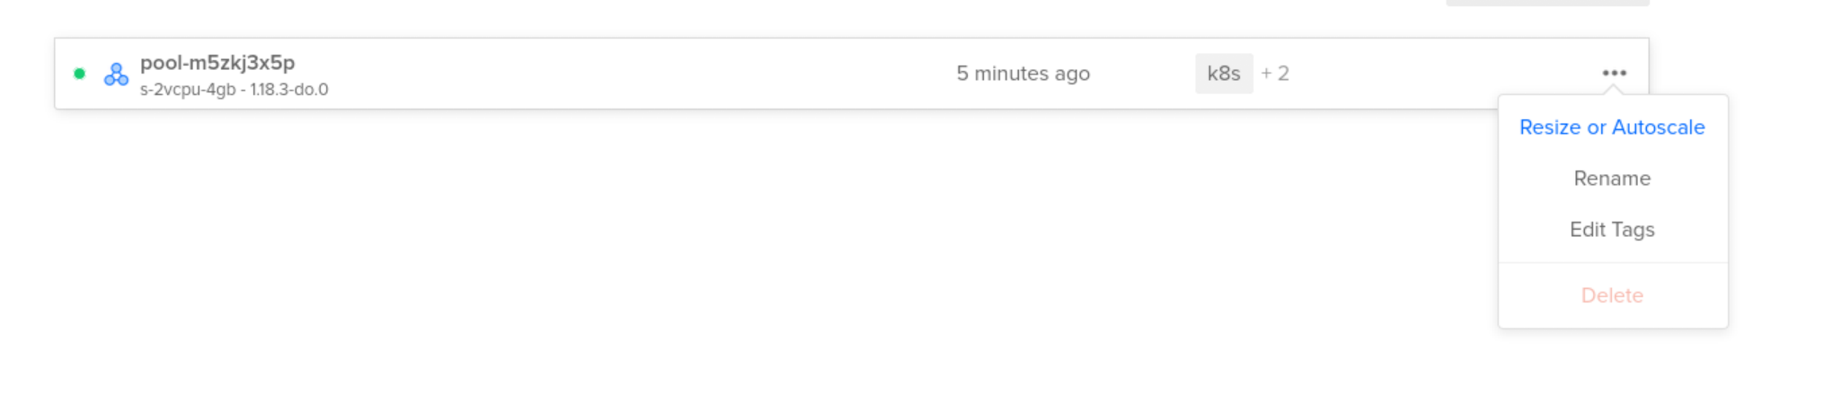

Add an extra node:  
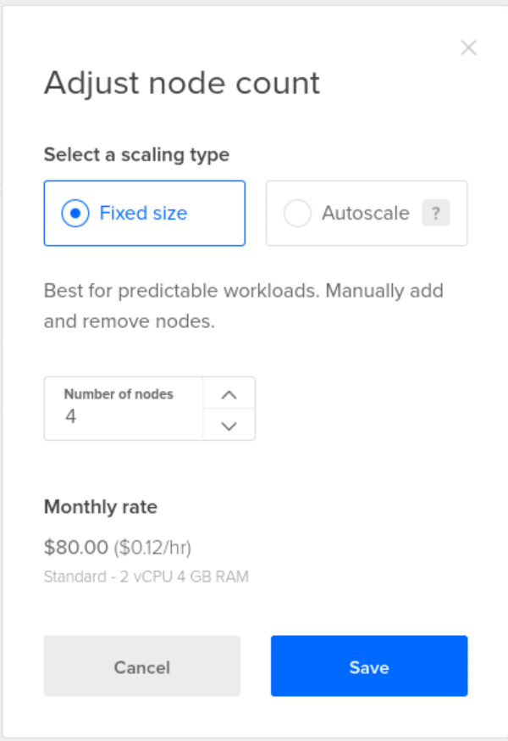

1. Wait until the new node is in place:

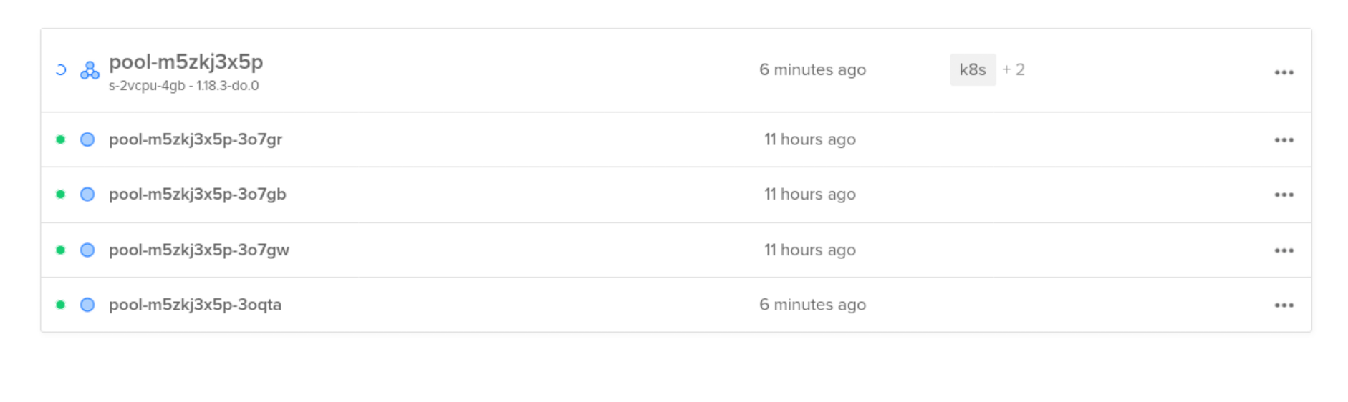

1. Quit the casstool shell (Ctrl-D)
2. Check from kubectl that the new node is active:  
     
   kubectl get nodes

NAME STATUS ROLES AGE VERSION

pool-m5zkj3x5p-3o7gb Ready <none> 11h v1.18.3

pool-m5zkj3x5p-3o7gr Ready <none> 11h v1.18.3

pool-m5zkj3x5p-3o7gw Ready <none> 11h v1.18.3

pool-m5zkj3x5p-3oqta Ready <none> 5m57s v1.18.3

1. Use either the Kubernetes Dashboard or k9s or kubectl to see how the pods are assigned to nodes. Unfortunately we are unbalanced, because Kubernetes hasn’t had any impetus to move the extra pod to the new node.
2. Rerun the stress test and see what the performance is like. Why isn’t it better?!
3. We have two options. We could just create a few more Cassandra nodes to more evenly use the nodes. However, there is another option using a cool tool called the Kubernetes Descheduler:

<https://github.com/kubernetes-sigs/descheduler>

1. In a window do this:

export KUBECONFIG=~/.kube/k8s-cass-kubeconfig.yaml

git clone https://github.com/kubernetes-sigs/descheduler.git

cd descheduler  
kubectl create -f kubernetes/rbac.yaml

kubectl create -f kubernetes/configmap.yaml

kubectl create -f kubernetes/job.yaml

1. Watch what happens using k9s
2. Once the pod has moved, all the cassandra pods should be on different nodes:  
   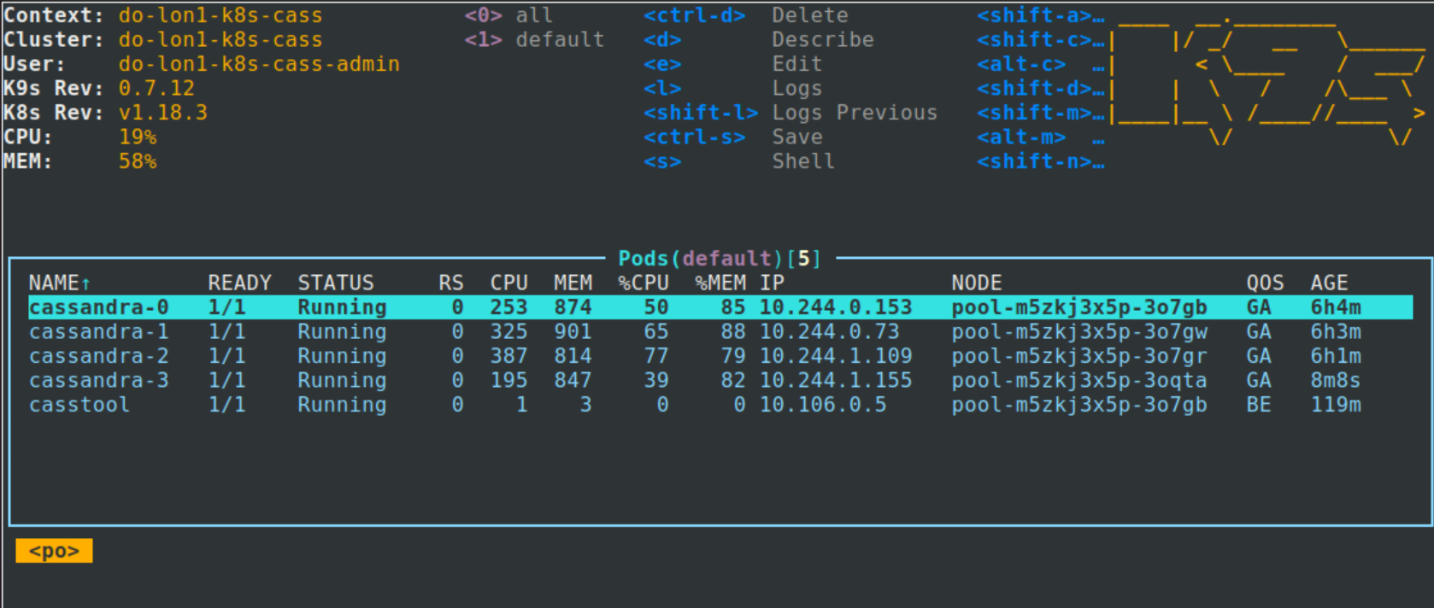

1. Now rerun the stress test one more time:  
   You can see my results were considerably better:  
   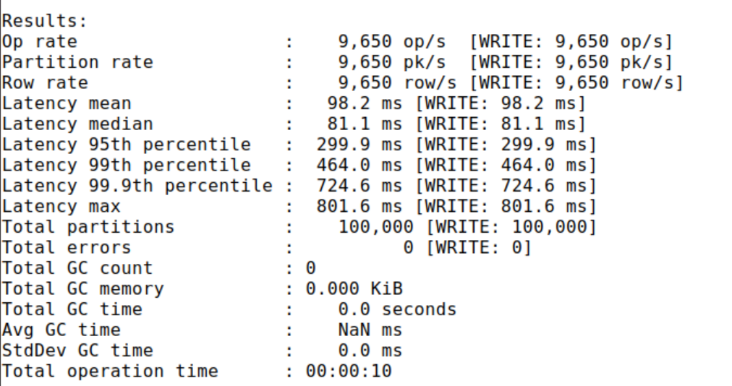
2. Congratulations - we have deployed cassandra, scaled it, tested it and increased performance all in a kubernetes cluster.
3. Let’s clean up.
4. Firstly, let’s delete our cassandra cluster.   
     
   cd ~/cassandra

kubectl delete -f cassandra-statefulset.yaml

1. Delete our casstool pod:

kubectl delete pod/casstool

1. Delete the volumes / volume claims:  
     
   kubectl delete persistentvolumeclaim -l app=cassandra
2. Delete the kubernetes cluster (from the DO web panel):

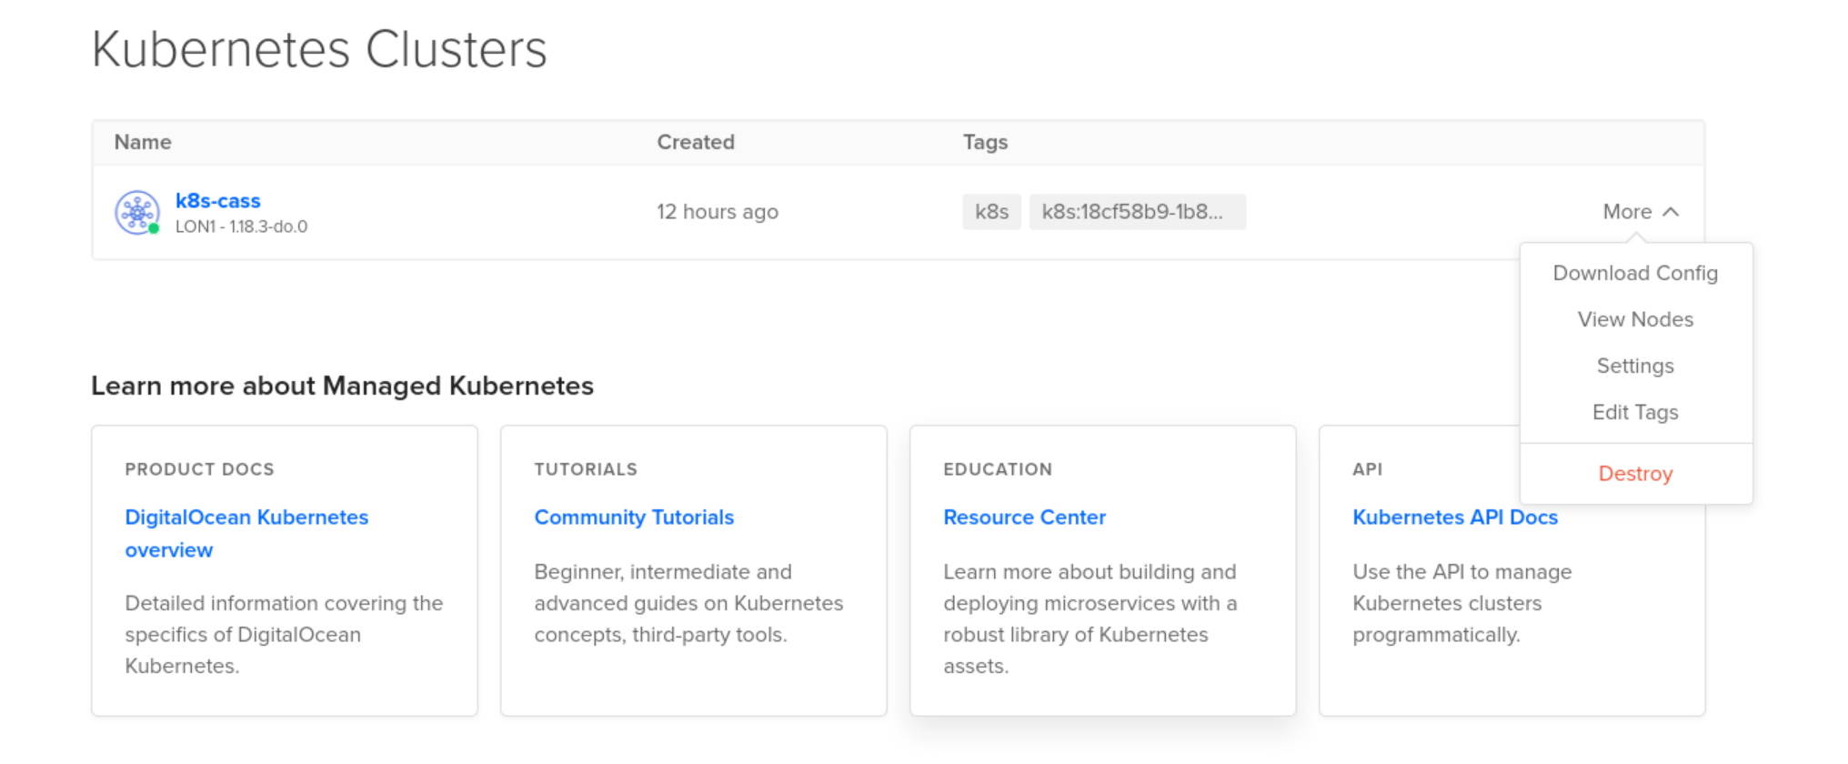

Click **Destroy**

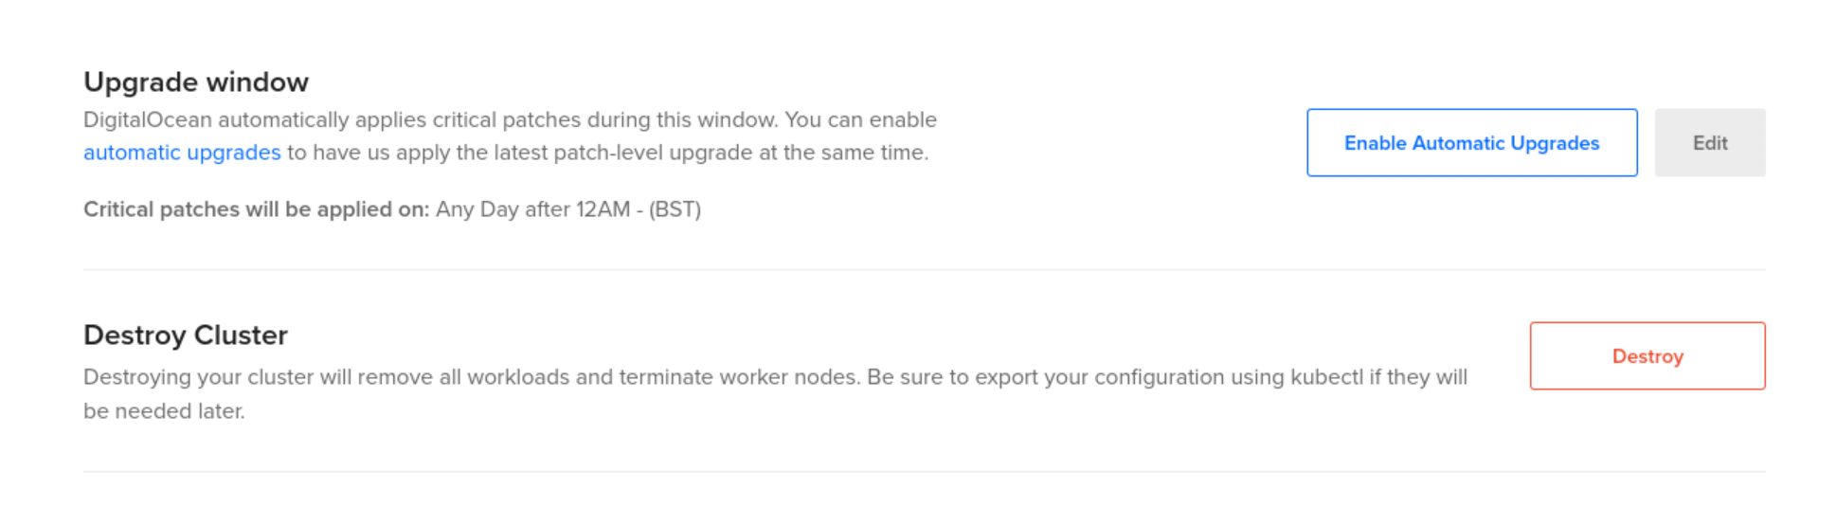

Then **Destroy** again.

Then enter the cluster name (k8s-cass) and actually finally **Destroy**

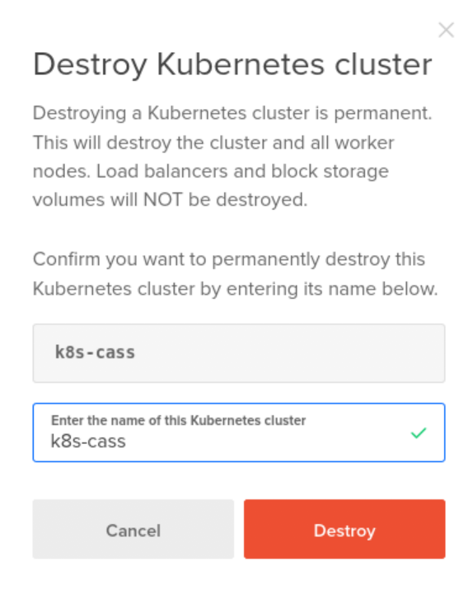  
51. If you came straight to this lab from the last one, you will also have one last remaining load balancer running.

DigitalOcean will also have created a load-balancer to handle the incoming traffic for your service. Go to **Networking -> Load Balancers  
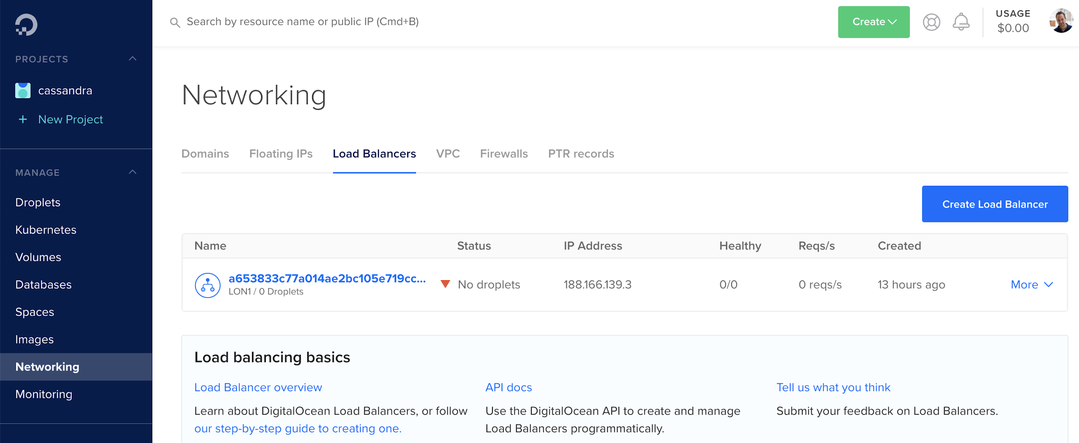**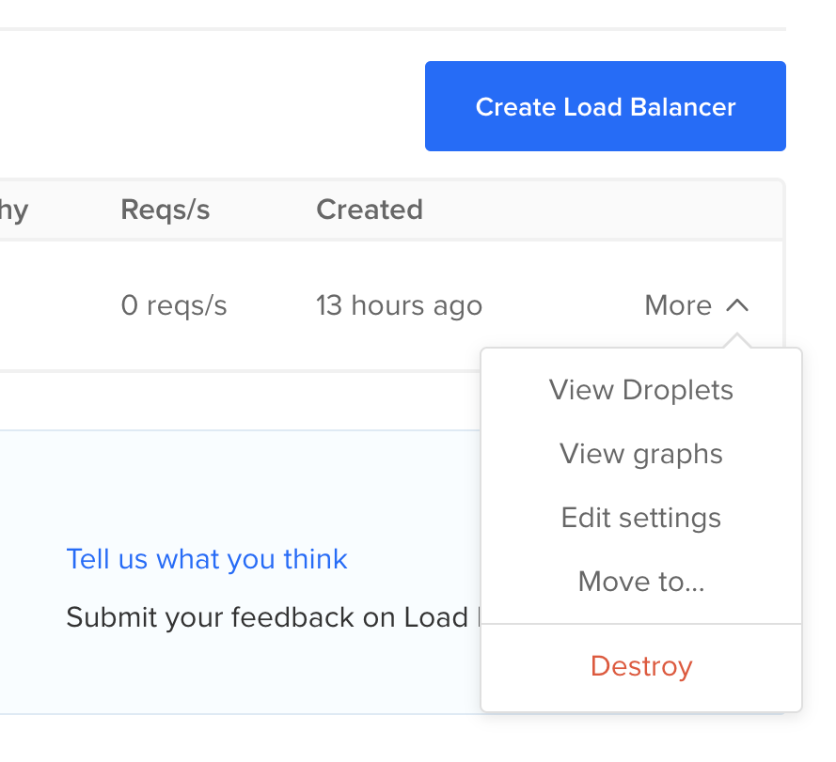

1. Click on **Destroy** and once again enter the name (copy and paste!)  
   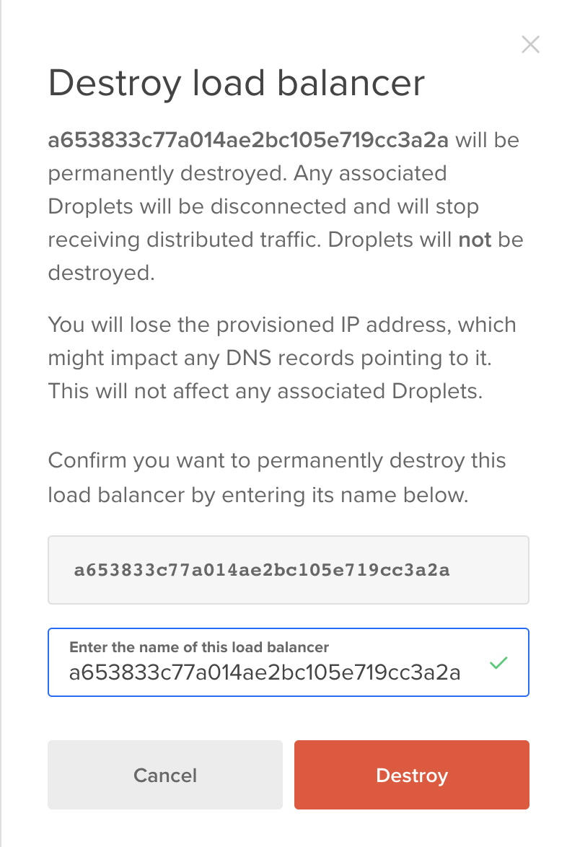
2. Have a hunt round all the resources in DigitalOcean and just check you haven’t left anything running!
3. This lab is done! Congratulations.